**The Exiles Group Project Initial Research and Conceptualization:**

**Unique themes from games:**

**[1]**. “Untitled Goose Game” – By House House

This game is a very recent example of a game with a unique twist. Instead of thinking that the theme of a goose game is you heard geese or farming geese, etc. You are instead the goose, going around honking at everyone and anything. It’s a simple exploration based indie game, with a simple set of mechanics involved and a cartoon art style that gives the game a lot of colour and character. It’s design of subverting the expectation of a player is the theme I want to extract of this game and possible attempt to use a similar theme for the group game.

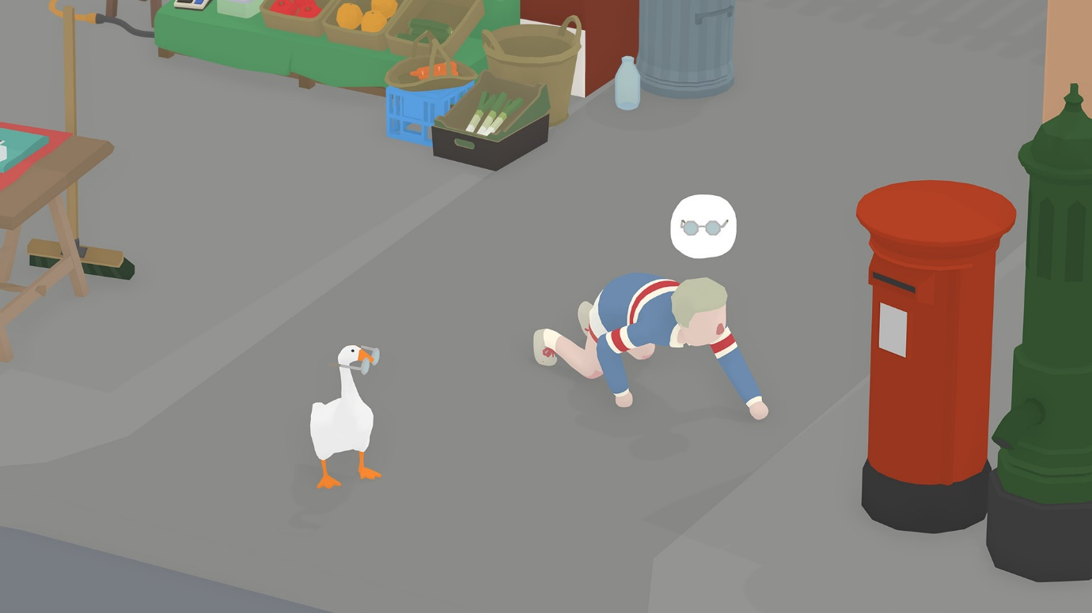

**[2].** “The Stanley Parable” – By Galactic Café

The Stanley Parable was an incredibly unique game with it’s reality bending exploration and wall breaking narrative, it really took the standard exploration puzzle game to the extreme. One of the things that resulted from gameplay was the increase in something called ‘Player Agent Curiosity’, which is ***“where the player is engaged with the game by poking and prodding it—sometimes in hope of breaking the game.” (Farrell, 2014)***

It’s the alternative and twisted reality of the game that interests me the most. The choices given to the player and the questions, puzzles and other conundrums that the player needed to overcome was delivered in a very linear yet satisfying way. The result of which elicited very strong negative and positive emotions from the players, which is a heavily desired effect in games.

[3]. “Paper’s Please” – By Lucas Pope

Paper’s please is an interesting take on a management mechanic as it dynamically scales as you progress in the game. The whole game has a very simple mechanic of information management, but as more people and more information come through, the player must work quicker and more efficiently to get through each person. The difficulty of the game comes from the need to retain and remember an increasing number of informational rules and exceptions to detect inaccuracies or violating information.

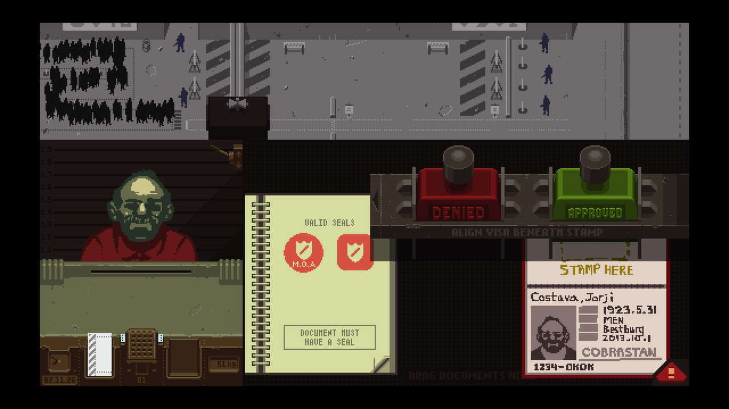

This game is another great example of a simple mechanic(s) that has a theme built around it being both accessible and understandable to players, but also dynamic and easily applied to an increasing and more complex situation that challenges the player more and more.

The forever changing situation of information management is something that would be an interesting mechanic to apply to a simplistically designed theme for a game.

[4]. “Limbo” – By Playdead

Limbo is a classic example and perfect combination of simple yet refined mechanics and a unique simplistic art style. Its dark monotone art style is purposely eerie and creepy to create the perfect atmosphere for producing profound emotion from the players. But when you look at the mechanics involved in the game, there isn’t a huge list of very complex actions that can be done, this is again done on purpose.

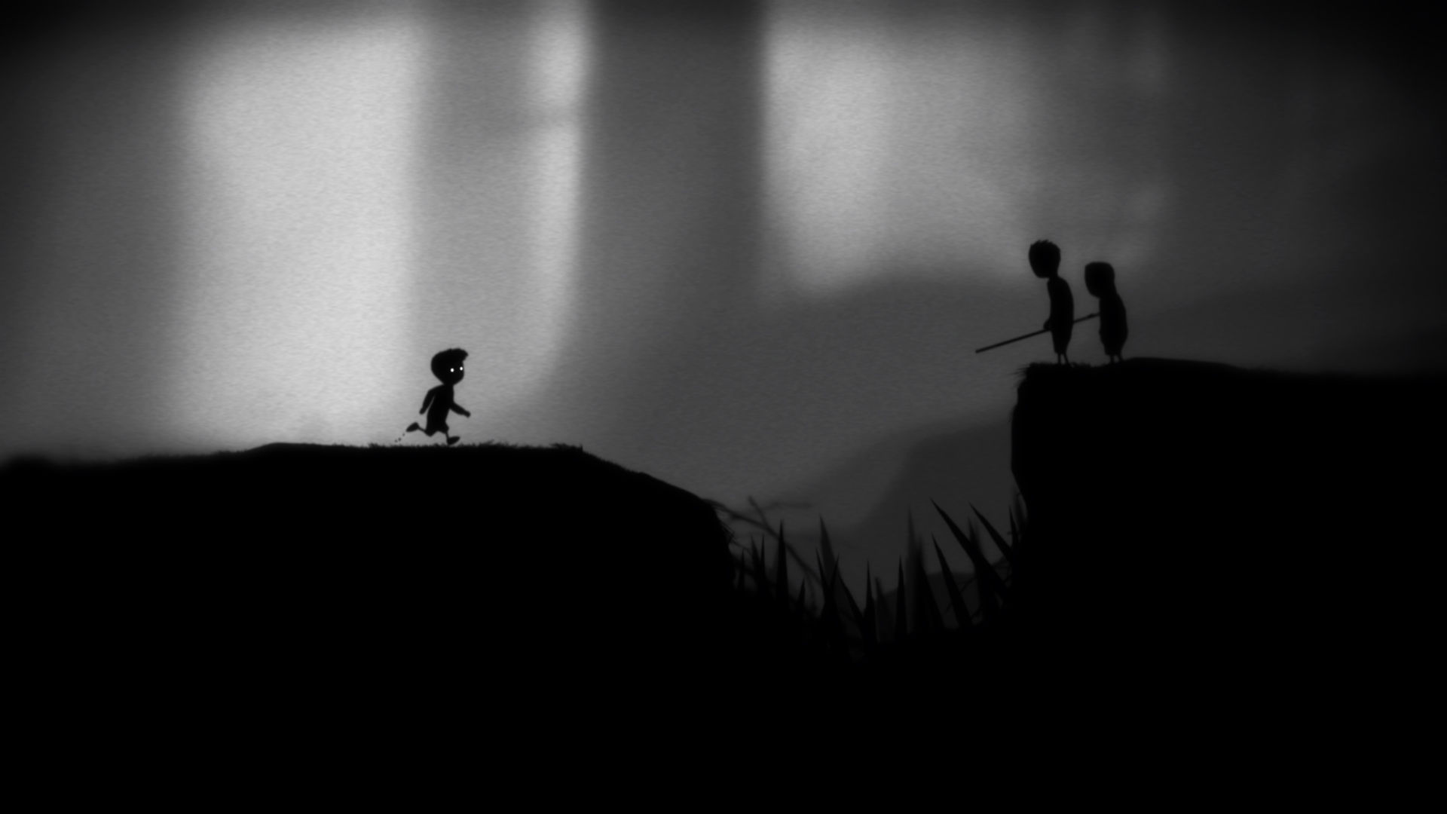The progression of the game perfectly utilizes all existing mechanics in a very intuitive and smooth manner, but also allows the player to eventually overcome the harder more intense obstacles that the game may throw their way, through the mastery of these simple mechanics.

It’s that level of refinement in our mechanics that we want in a game. We **DON’T** want to give the player a few mechanics that they spend forever trying to master. Want we want is a set of basic mechanics and actions that can be applied to both easy and hard situations, we want to give the player enough breathing space to master these actions and apply them to any scenario thrown at them.

Unique mechanics from games:

***“If you look at games as being about exploratory learning, they tend to teach the player a series of skills. First, the player learns basic skills (such as how to press a button) and, over time, assembles a scaffold of skills that lets him engage in more complex scenarios like "save the princess." Each moment of learning gives a burst of pleasure.” (Cook, 2008)***

This is ideally what we want in our game. Our game needs to have a small set of simple yet effective mechanics that provides the player with both simple starting actions as well as the ability to achieve more complex actions using the same base mechanics, that will be the desired result.

An example would be the ability to move objects around and interact with buttons. To start with the player can use these mechanics to move around and complete basic puzzles and actions, however later in the game they can also use the very same mechanics to complete and interact with more elaborate contraptions and puzzles.

Subverting the expectation of the player is something highly desirable in games. Games that take a normal concept and twist it or warp it into something unusual is great theme to work with. Alternate reality-based games and swapping roles in games are some of the most interesting concepts as they create a new dynamic to gameplay and create a very profound level of awe in a player as they explore this newly twisted world, or get to know this highly unusual character arc.

However, when doing this and trying to achieve this it’s important to remember that ***“as developers we must understand that to break the rules and turn the expectation on its head, we must first make sure the player understands the patterns of the mechanics***” ***(Gamasutra.com, 2016).*** If we want to surprise the player narrative wise we first need them to be grounded in the pre-existing world, rather than the twist coming from nothing we must first build up their expectation for something to happen in a particular manner.

My Game Concept(s):

[1]. The war of the Waste, an over the shoulder fortress defence game about eliminating wave after wave of anthropomorphised rubbish and various plastic waste. It will be a topical yet unique take on global warming and on pollution of rubbish and the fight for the survival of wildlife in the ocean.

The player will play as a “Anti-Plastic’s defence Soldier” tasked with the defence of a local beach. The player will need to use the mouse to aim and click to fire ammunition at the walking plastics that are trying to reach the sea to further pollute the ocean.

The controls would be a simple mouse control to aim the canon and click to shoot. Later down the line, there may be other buttons to press for special actions/attacks. The objective would be to survive through as many waves as possible and rack up as high of a score as possible, this will allow the game to have a sense of competitiveness amongst players. There would also be a leader board system to go with this.

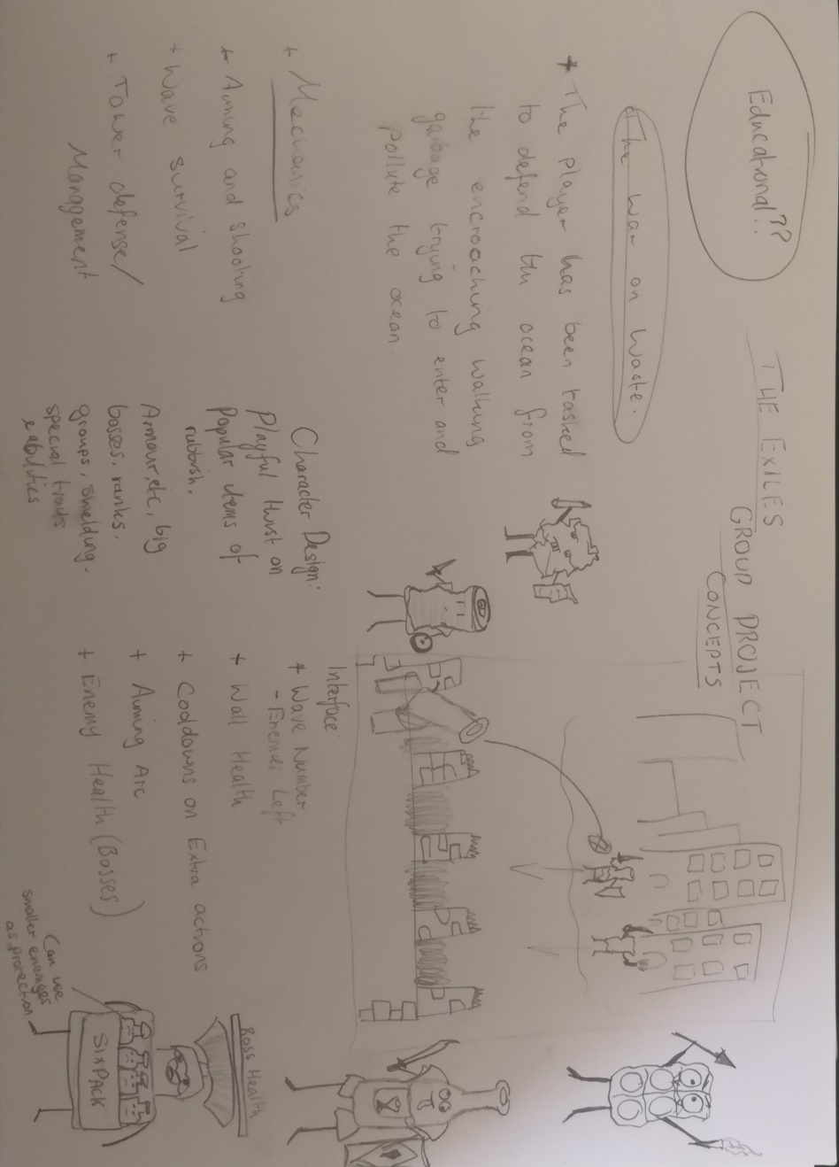

Bibliography List:

Cook, D. (2008). *Analysis: On Theme And Game Design*. [online] Gamasutra.com. Available at: https://www.gamasutra.com/view/news/111642/Analysis_On_Theme_And_Game_Design.php [Accessed 26 Sep. 2019].

Farrell, J. (2014). *6 Games That Succeed Because They're Interesting, Not Because They're Fun*. [online] Game Development Envato Tuts+. Available at: https://gamedevelopment.tutsplus.com/articles/6-games-that-succeed-because-theyre-interesting-not-because-theyre-fun--cms-21629 [Accessed 26 Sep. 2019].

Gamasutra.com. (2016). *Subverting Player Expectation*. [online] Available at: https://www.gamasutra.com/blogs/PeteEllis/20160310/267757/Subverting_Player_Expectation.php [Accessed 28 Sep. 2019].

Store.steampowered.com. (2019). *LIMBO on Steam*. [online] Available at: https://store.steampowered.com/app/48000/LIMBO/ [Accessed 28 Sep. 2019].

Papers, P. (2019). *Papers, Please on Steam*. [online] Store.steampowered.com. Available at: https://store.steampowered.com/app/239030/Papers_Please/ [Accessed 28 Sep. 2019].

Parable, T. (2019). *The Stanley Parable on Steam*. [online] Store.steampowered.com. Available at: https://store.steampowered.com/app/221910/The_Stanley_Parable/ [Accessed 28 Sep. 2019].

Game Informer. (2019). *Untitled Goose Game Review – The Joys Of Goosing Around*. [online] Available at: https://www.gameinformer.com/review/untitled-goose-game/untitled-goose-game-review-the-joys-of-goosing-around [Accessed 28 Sep. 2019].